**Big Data – Case Study**

**Student Name: Srinivasahanumantha Ramasarma Annaparthi**

**Student Id: sxa170055**

**Date: 4/30/2019**

Objective: The objective of this case study is to analyze sentiments from twitter of a highly spoken-of event that took place on 8th November 2016 in India. To combat the black money problem in the country, the government decided to demonetize two bills of the highest denominations. We will analyze on how the users reacted to the event using a dictionary and further on, we will visualize the results obtained.

Table of Contents

Part-1: Setup: 2

Part-2: Sentiment Analysis: 4

Part-3: Visualization of Sentiments: 10

Part-4: Checksum: 16

Part-1: Setup: In this section we will set up the files and data that is required to progress throughout this case study.

Step-3: Execute the following command:



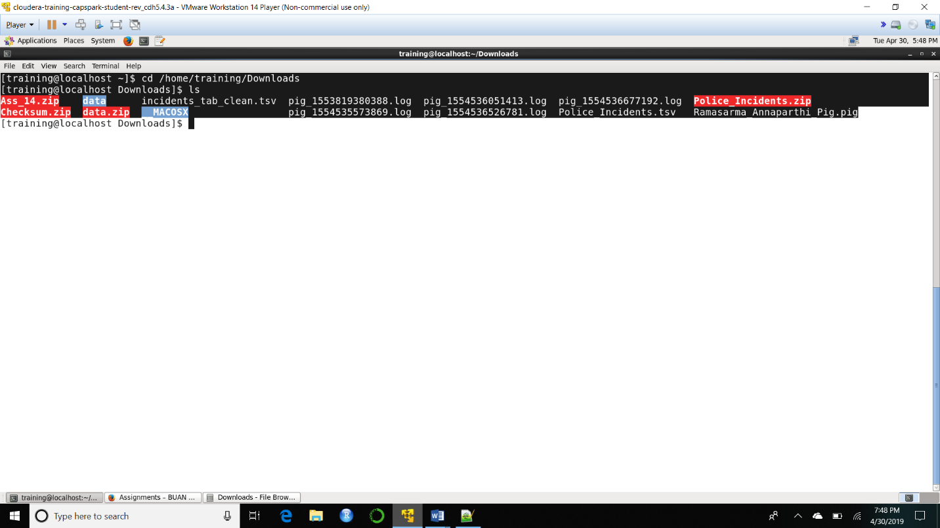Q. Now type the command and execute. Take a screenshot of the shell output, highlight the zip file and paste it below.

Step-4: Execute the following commands at the shell prompt:





Q. Now type the command and execute. Take a screenshot of the shell output, highlight the contents of the zip file and paste it below.

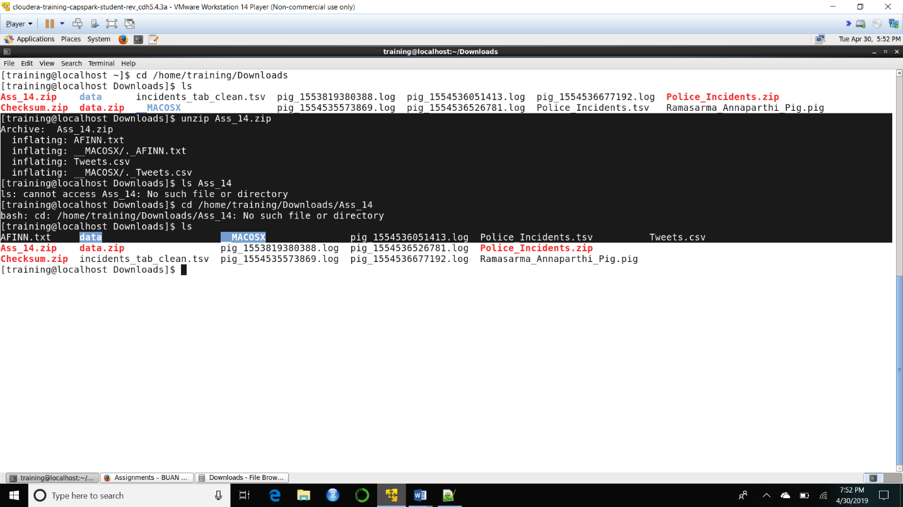Explanation: The “unzip” command unzips the zip file.

Step-5: Execute the following command at the shell prompt:

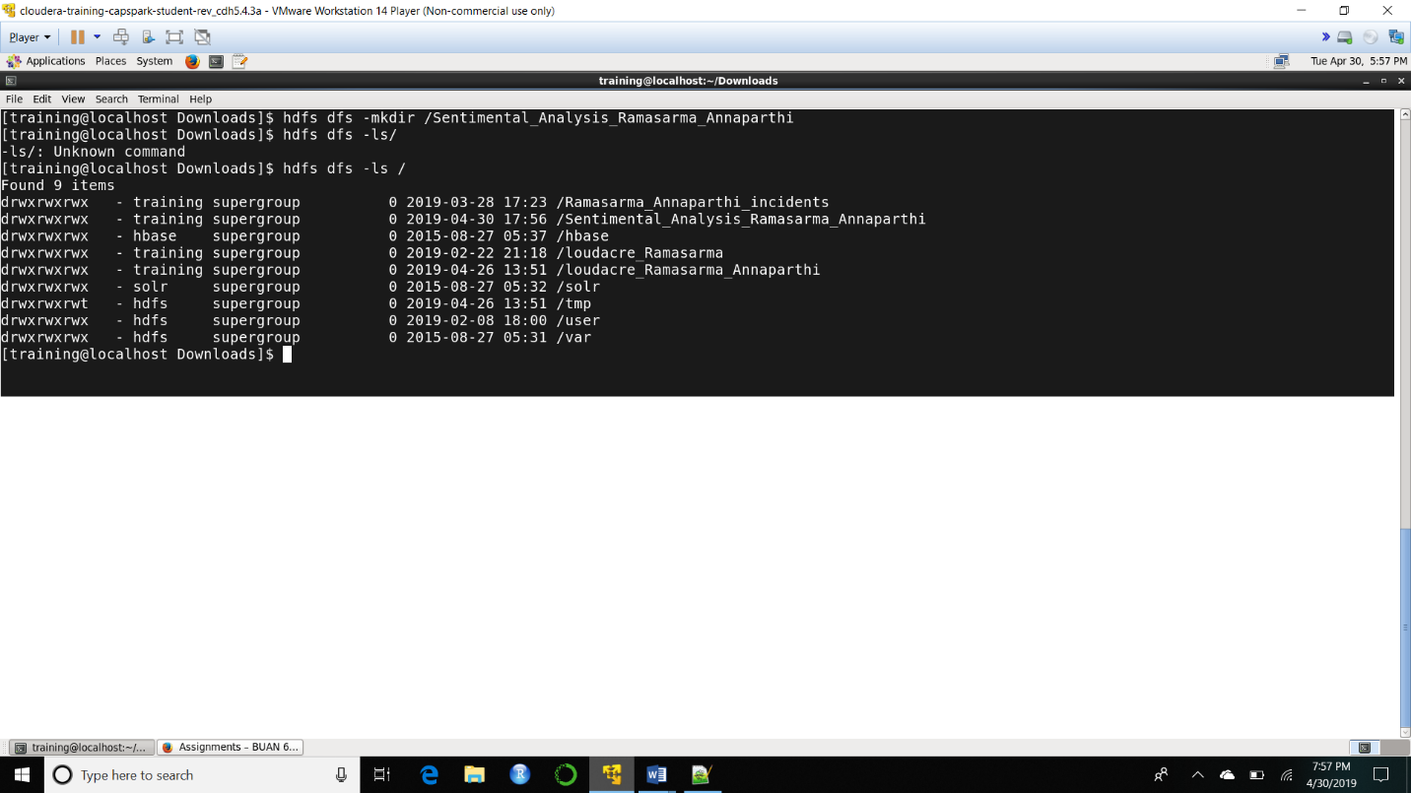

Explanation: We are creating a directory at the root directory for this assignment. We will be using this directory throughout the assignment.

Step-6: Execute the following 2 commands at the shell prompt:



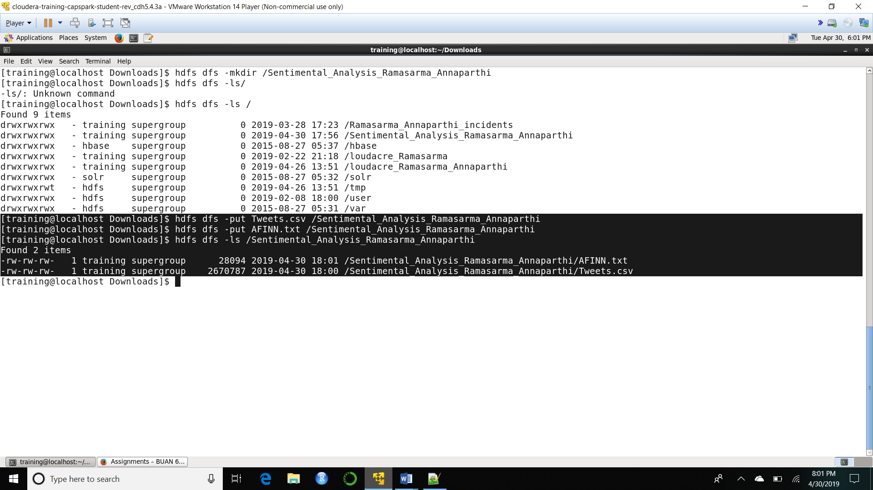Explanation: We are copying the data files required for this exercise into the directory that we created in Step 5.

Part-2: Sentiment Analysis: In this section we will perform a sentiment analysis on tweets regarding Demonetization in India.

Step-7: Execute the following command at the shell prompt:



Explanation: The above command invokes the grunt shell. The grunt shell is an interactive shell to execute pig commands & scripts. The command above can be followed by various additional configurations but for our use case the stand grunt shell will suffice.

Step-8: Execute the following command at the grunt shell prompt:



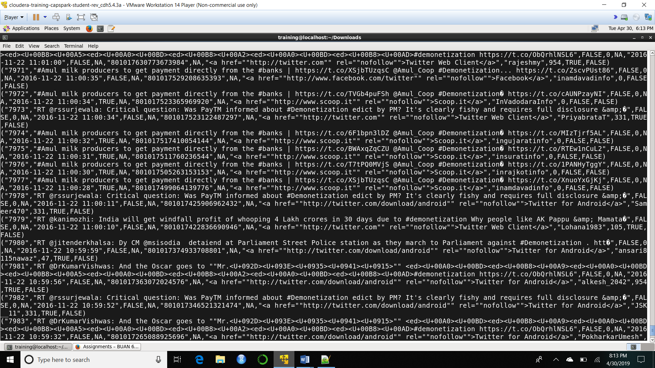

Explanation: The dump command displays the data for the variable specified in the grunt shell.

Step-9: Execute the following command at the grunt shell prompt:



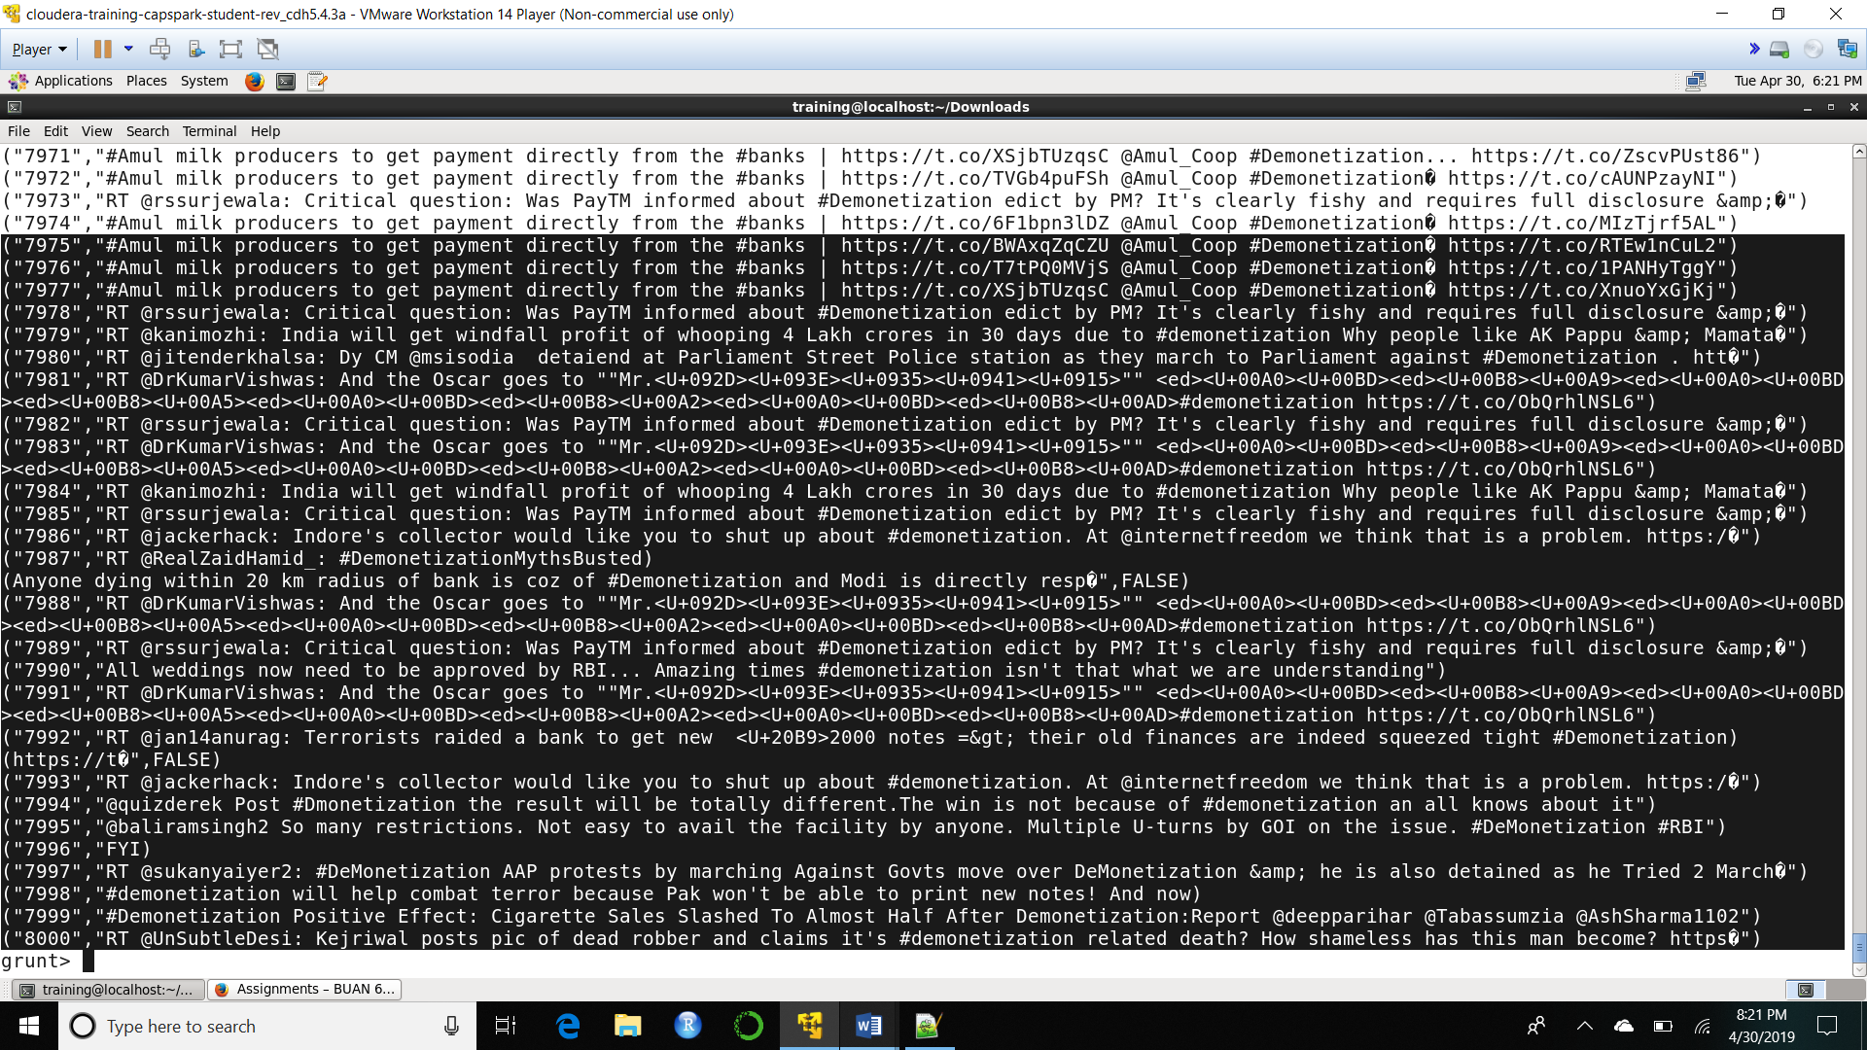

Explanation: We are defining and collecting the first two data elements in the csv file and dumping the data at the grunt shell.

Step-10: Execute the following command at the grunt shell prompt:



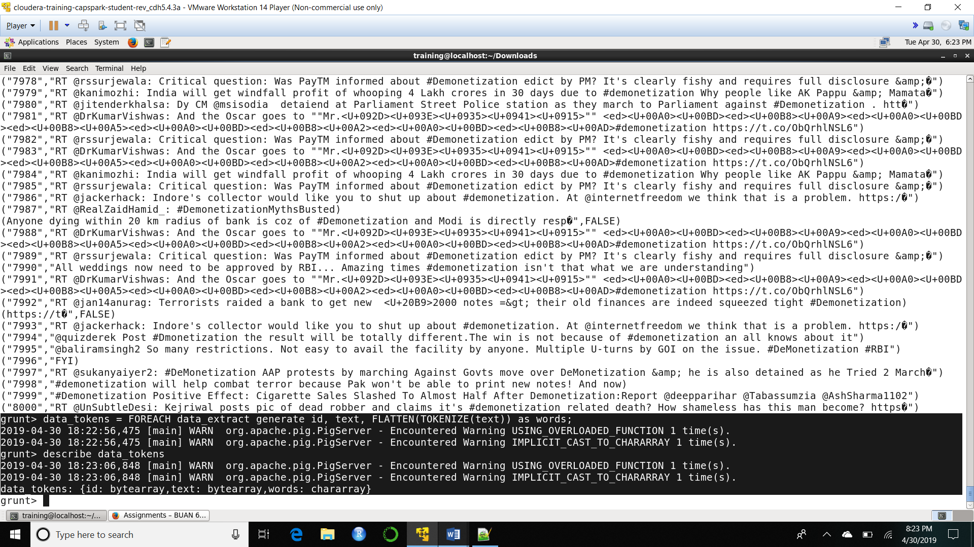

Explanation: We are defining a third element by breaking down the text information in the variable ‘text’ into words. The describe operation shows us the variable names and types of the data in the variable specified.

Step-11: Execute the following command at the grunt shell prompt:

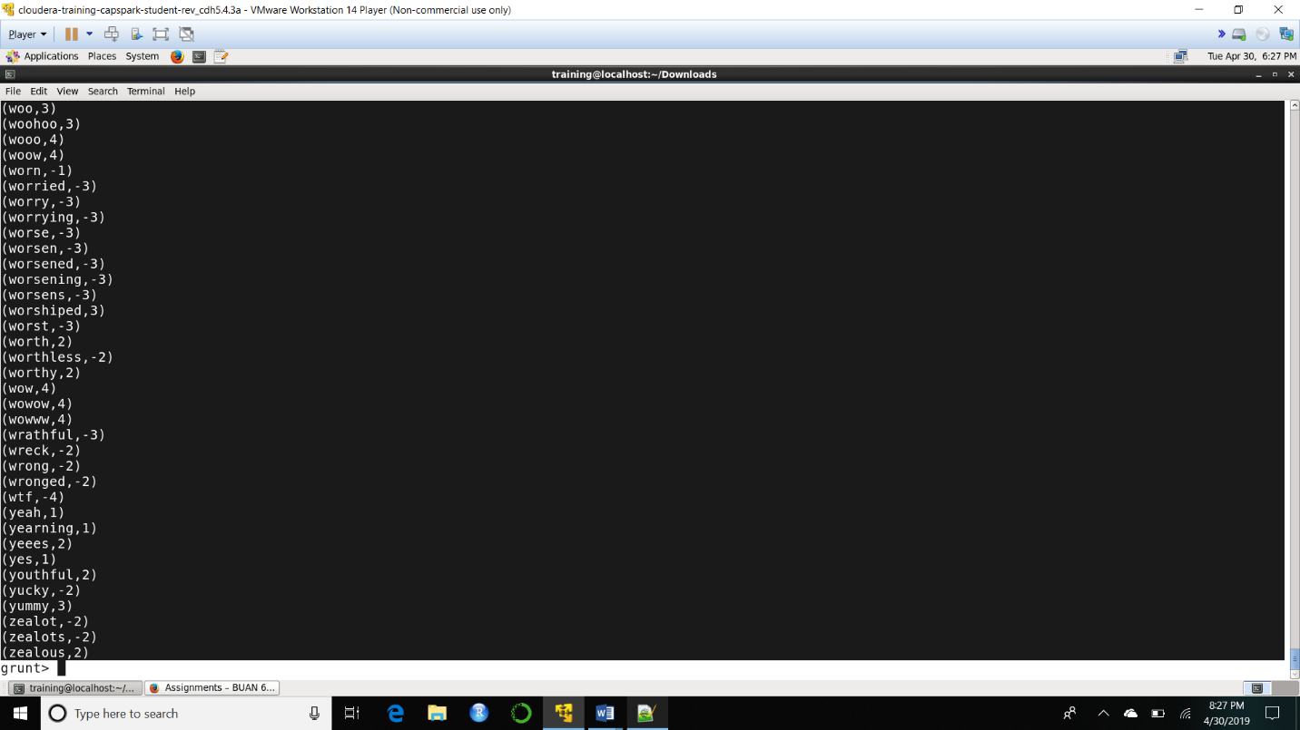

Explanation: AFINN dictionary is a dictionary consisting of 2500 words that are rated on a scale from -5 to +5 depending on the sentiment the word conveys. We will be using this dictionary to perform the sentiment analysis on our tweet data.

Step-12: Execute the following command at the grunt shell prompt:



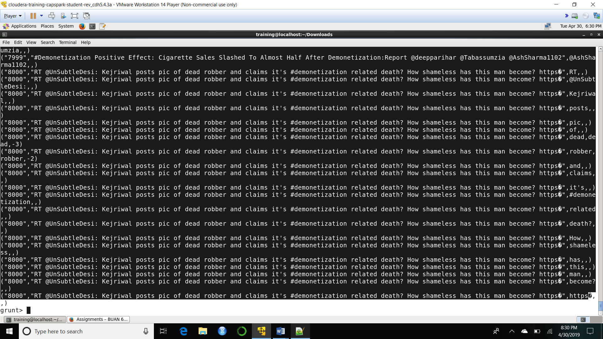

Explanation: We are joining the sentiments values from the AFINN dictionary with the words in the text from each tweet.

Step-13: Execute the following command at the grunt shell prompt:



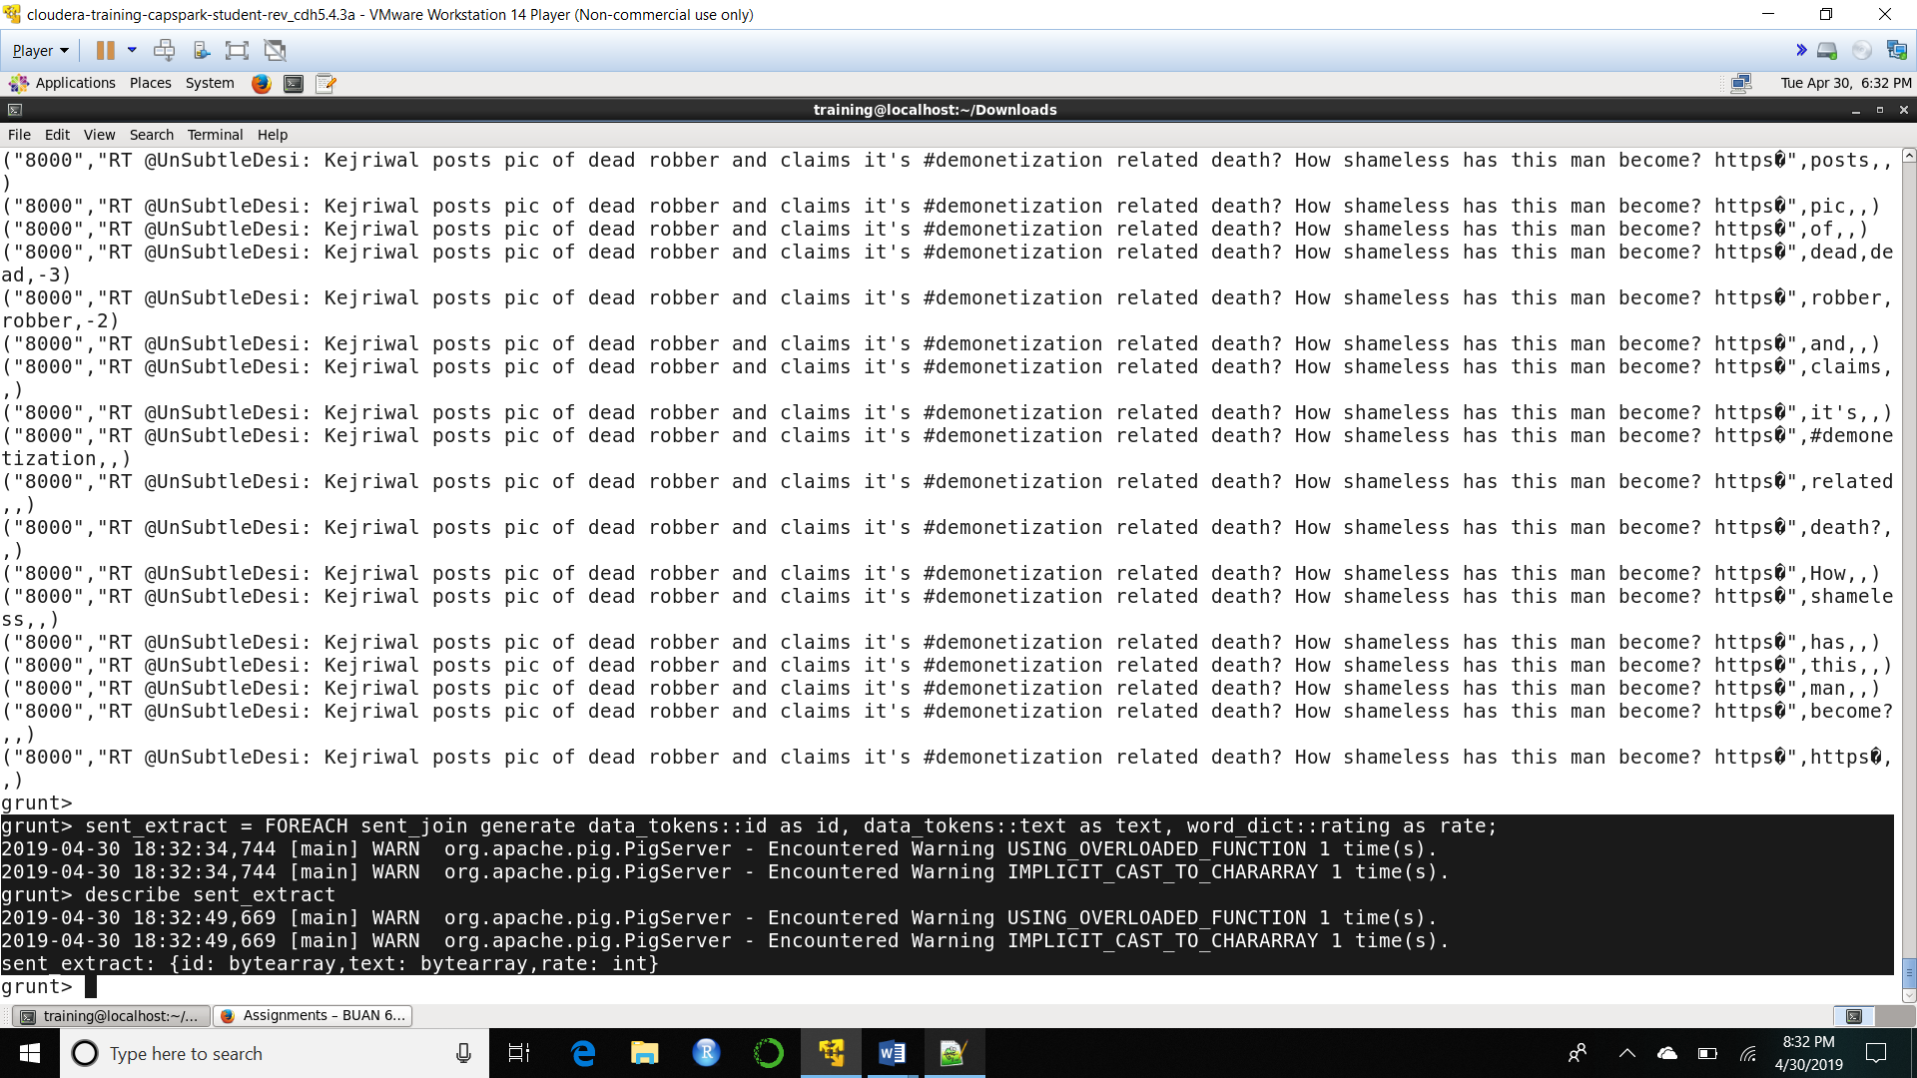

Explanation: We are now extracting the data from the variable in step 12 that we need to complete our sentiment analysis.

Step-14: Execute the following command at the grunt shell prompt:



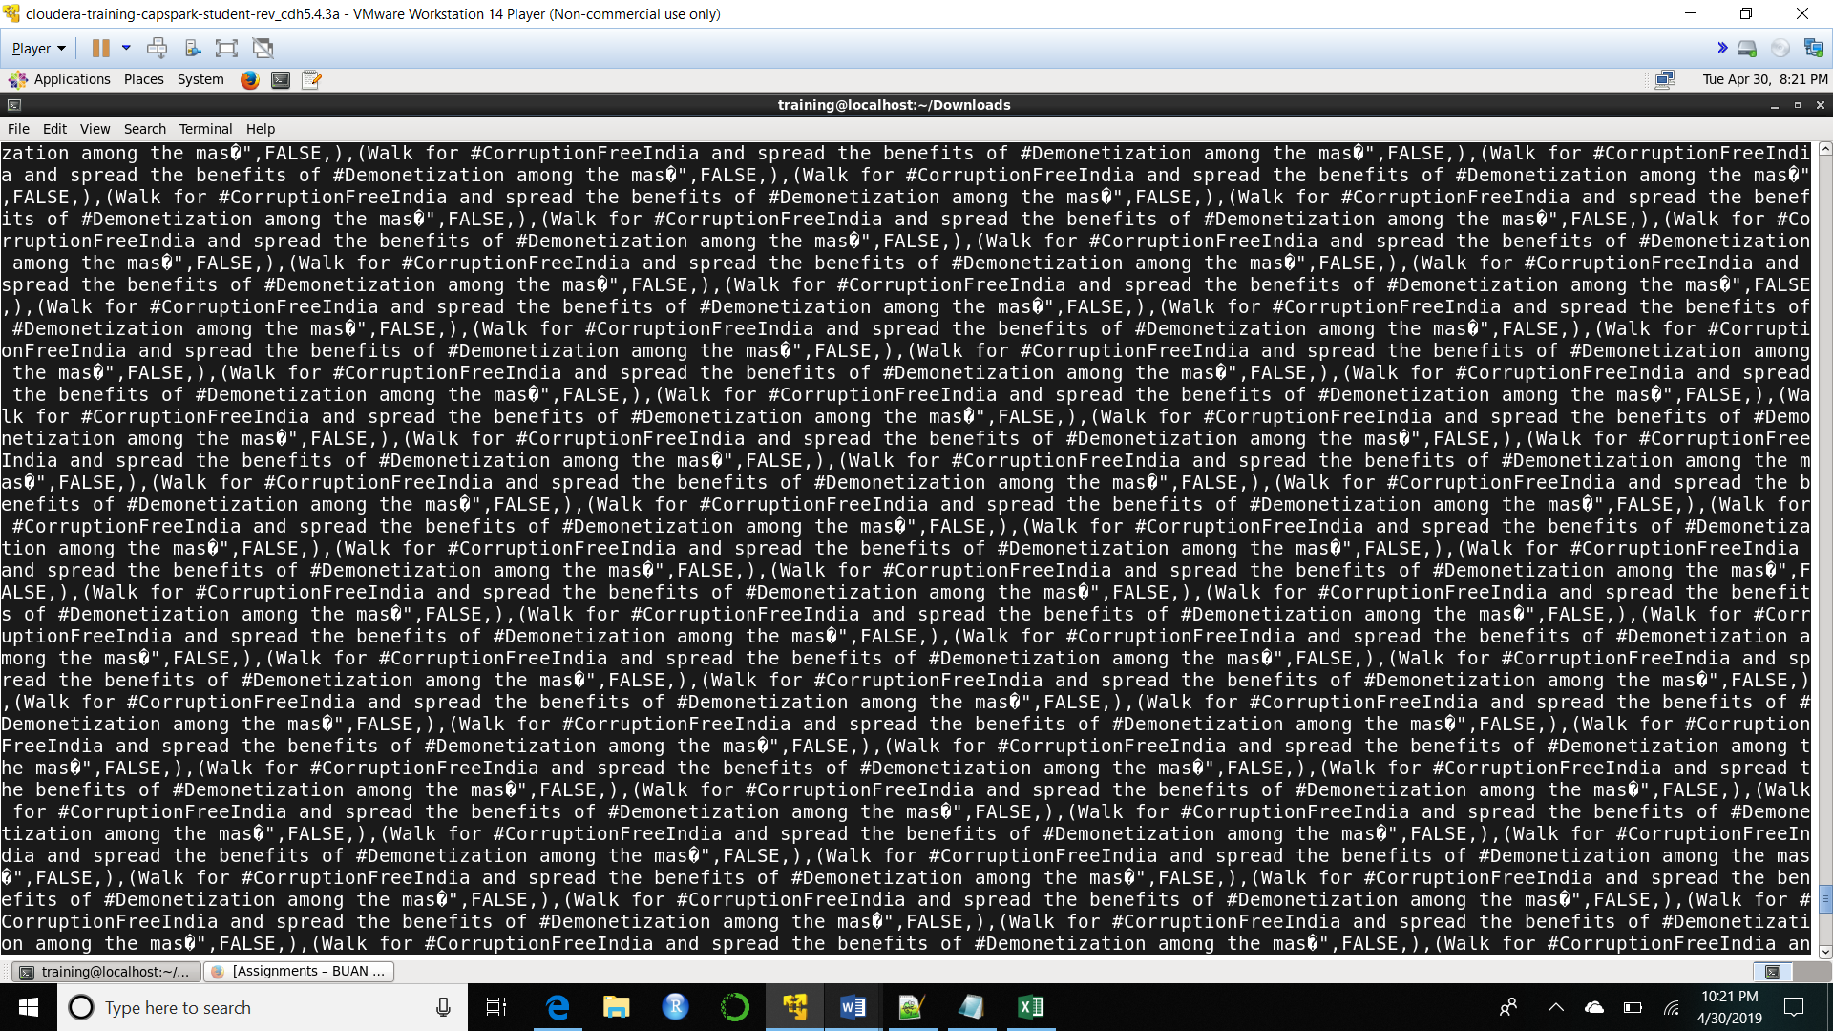

Explanation: We are grouping each record by its id and text.

Step-15: Execute the following command at the grunt shell prompt:



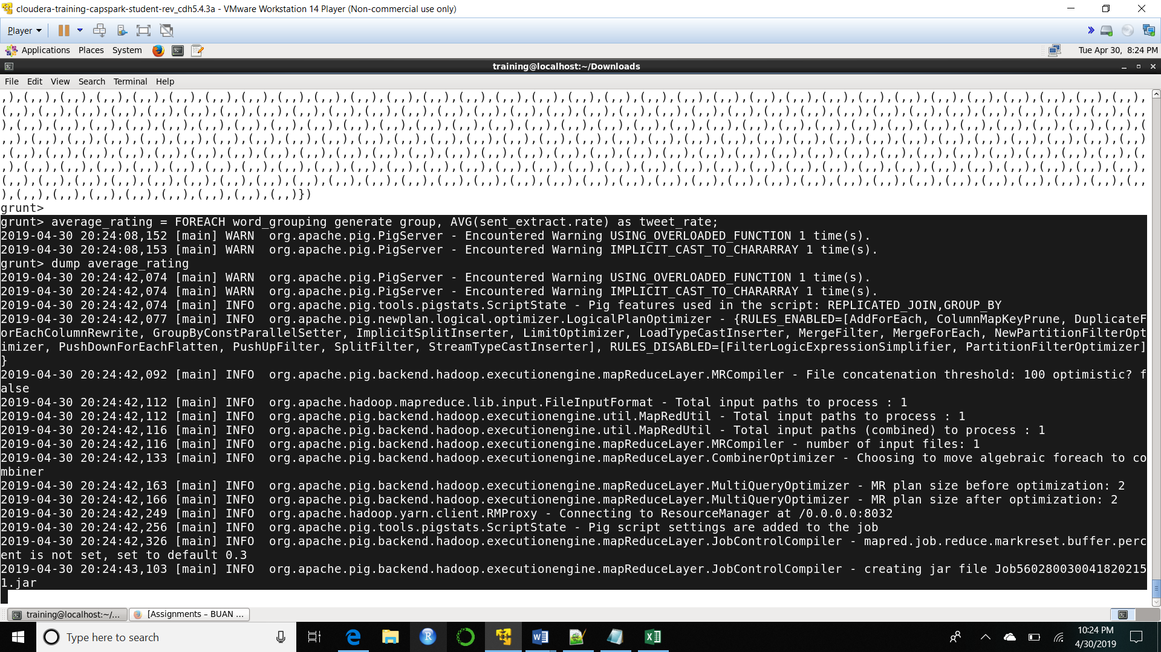

Explanation: We are averaging the rating for all the words in each tweet and storing the result in average_rating.

Step-16: Execute the following command at the grunt shell prompt:



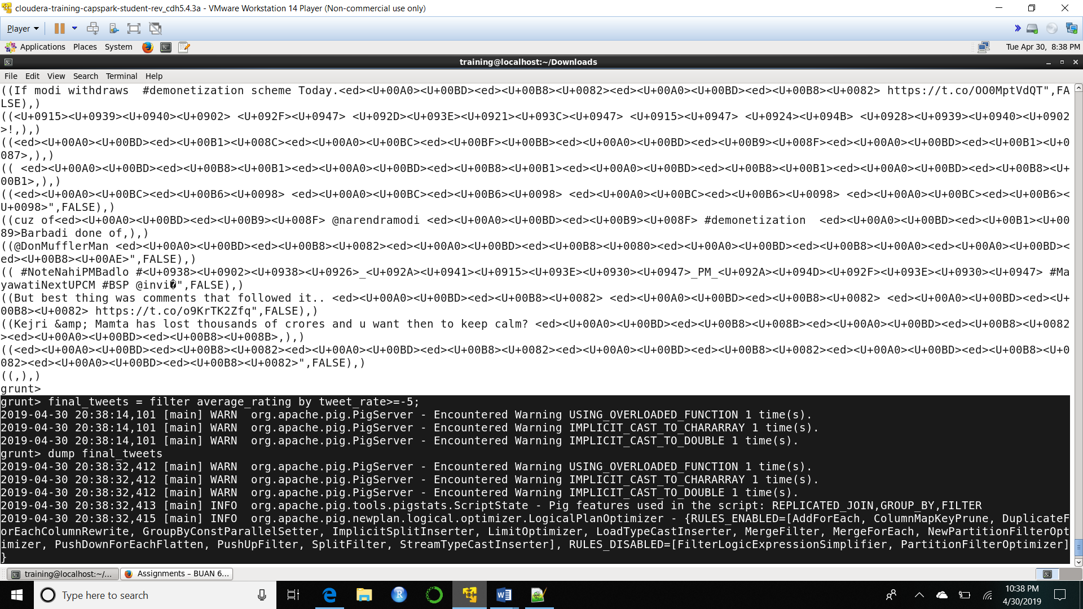

Explanation: We are filtering all the tweets for those tweets that have an average rating >= -5.

Step-17: Execute the following command at the grunt shell prompt:

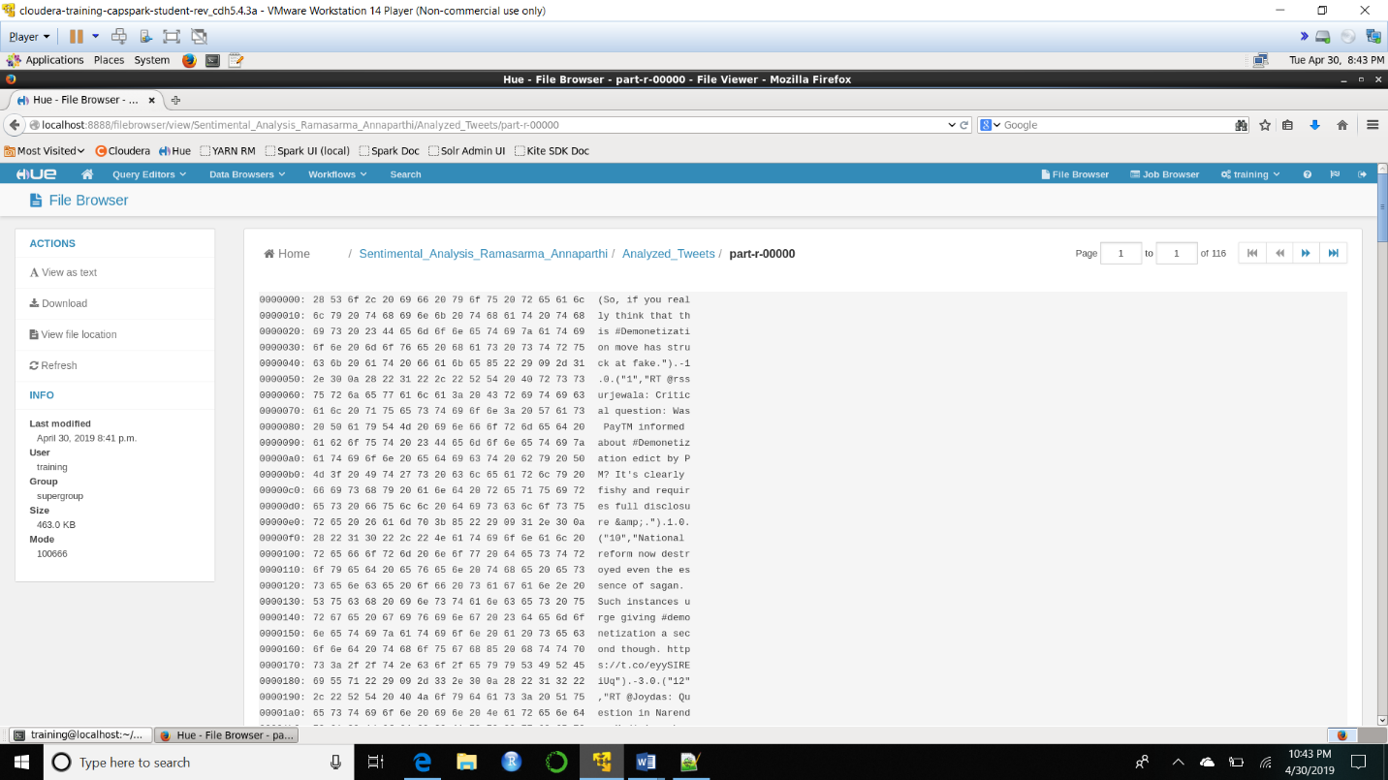

Explanation: We are viewing the output of the Analyzed_Tweets file in HUE.

Step-18: Execute the following command at the shell prompt:



Explanation: We are starting up beeline, to execute the hive commands. Beeline shell is an interactive shell based on the SQLLine utility.

Step-19: Execute the following command at the beeline shell:

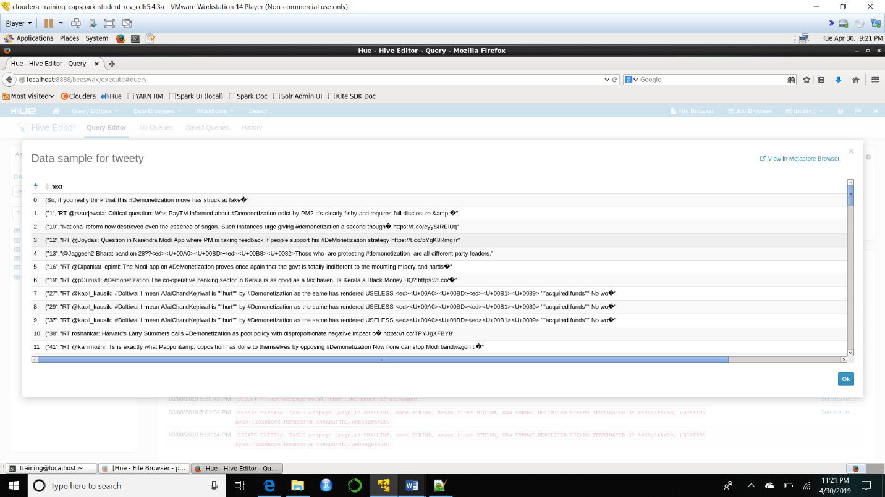

Explanation: We are creating a hive table to structure our unstructured data.

Step-20: Execute the following command at the beeline shell:

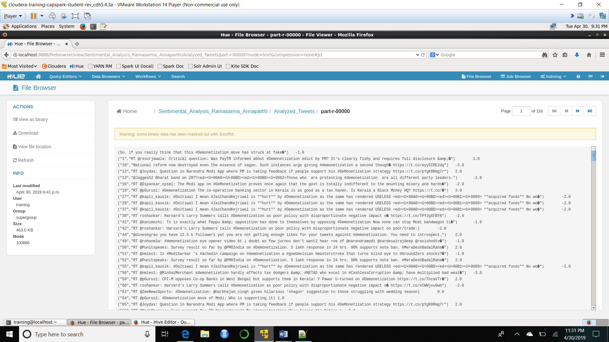

Explanation: We are now creating a tsv file from the table that we created in Step-20.

Part-3: Visualization of Sentiments: In this section we will visualize the results of our sentiment analysis using Jupyter notebooks.

Step-21: Exit Beeline then execute the following command at the shell prompt:



Explanation: We are copying the results of our sentiment analysis back on the local file system to visualize.

Step-22: Using Firefox, browse to the following address:

<https://jupyter.org/try>

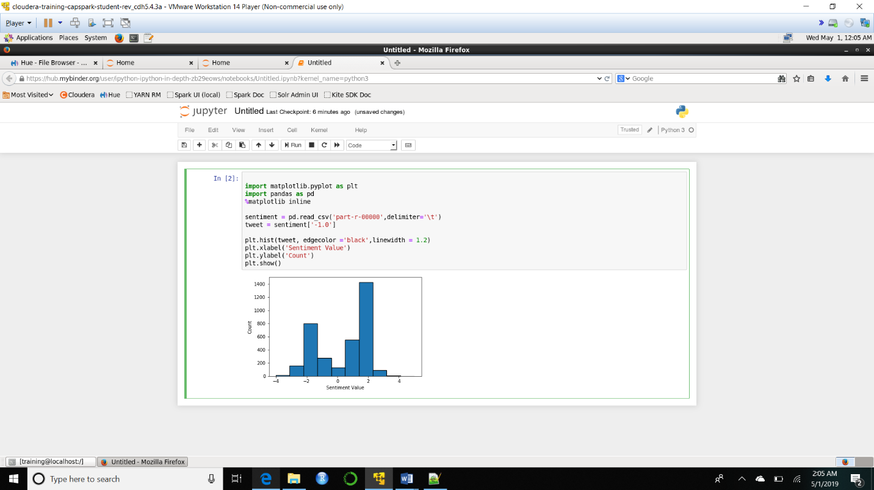Data Visualization of the analyzed tweets